Lab2:

1. Modify the index.html file, using notepad in your local system

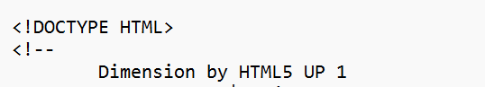

1. Click on upload, and upload the doc again

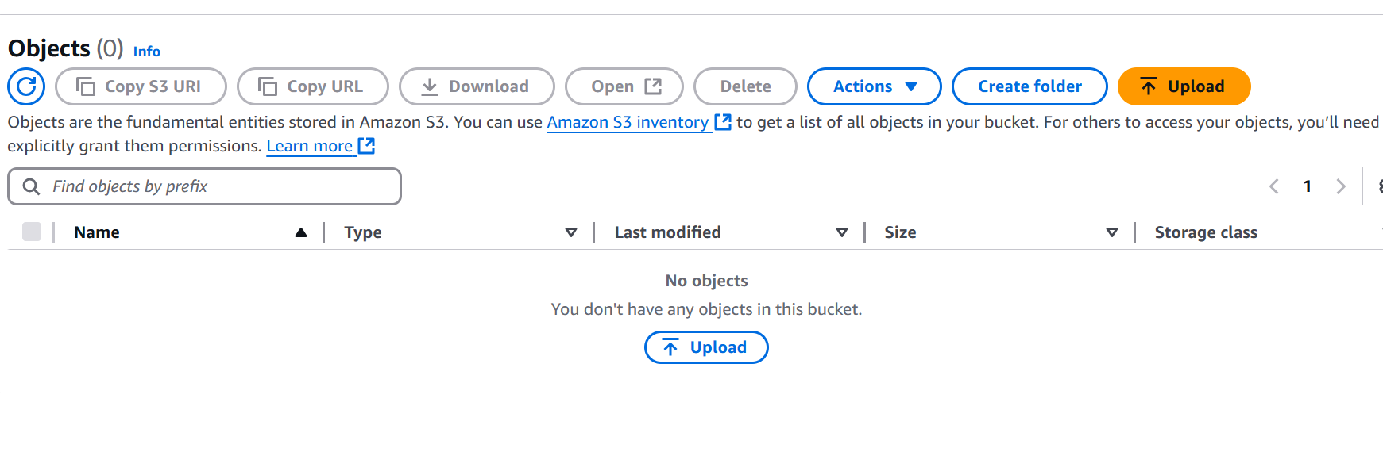

1. Add files

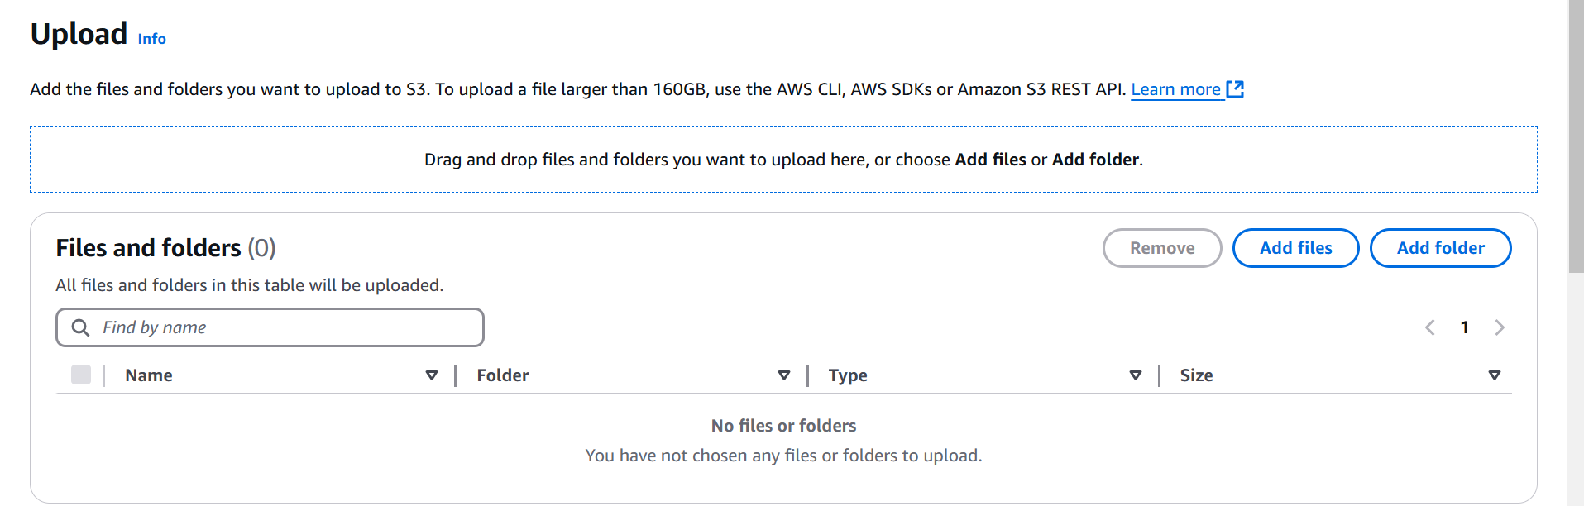

1. Now click on Properties option and enable the versioning
2. Properties->Edit option

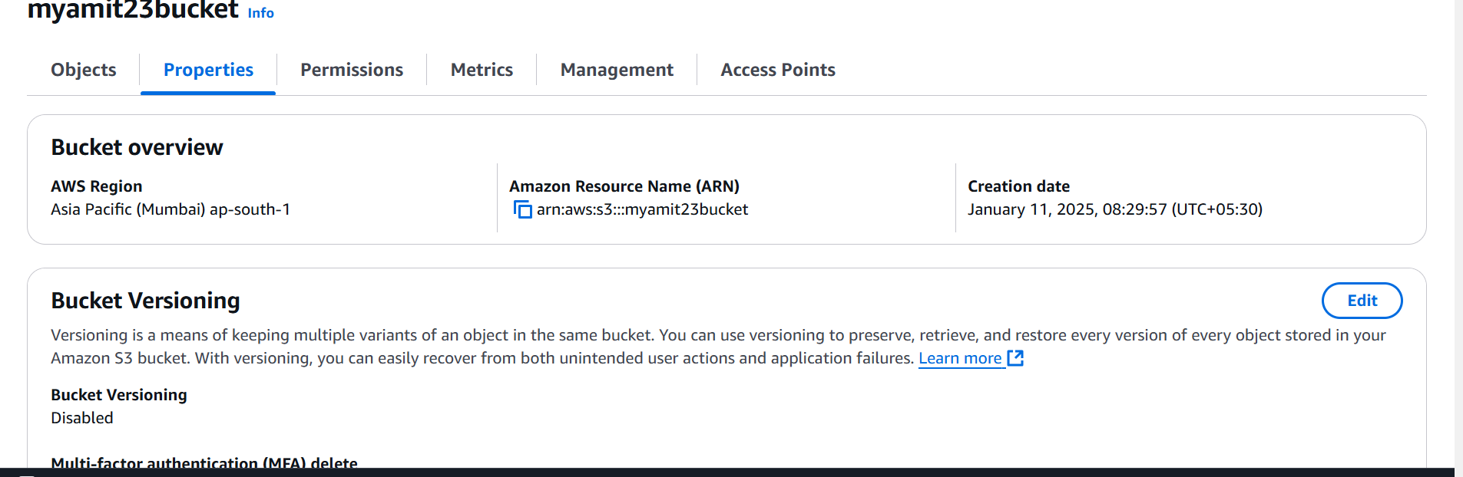

1. Enable versioning

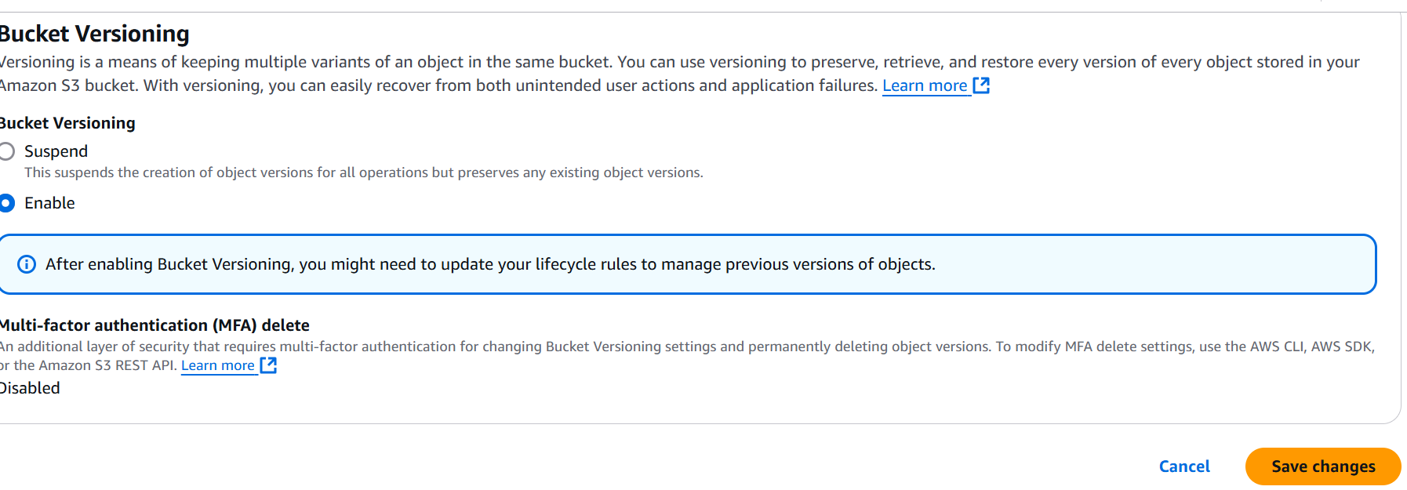

Check the version, click on show version tab, it will always point the latest one

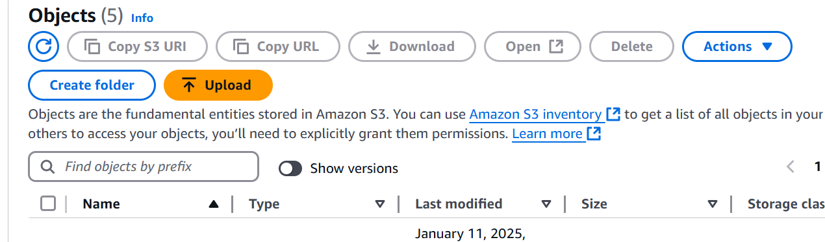

In case you delete it will go back to previous version, that is the way you will safegaurd